Polygon–Organic Mixed Shapes
# Source: AI Source: Provided by: [Data Path: Persons Table -> ID Column: 1, Name_En Column: Motasem Essam] -> From: [ChatGPT] on [7/25/2026]
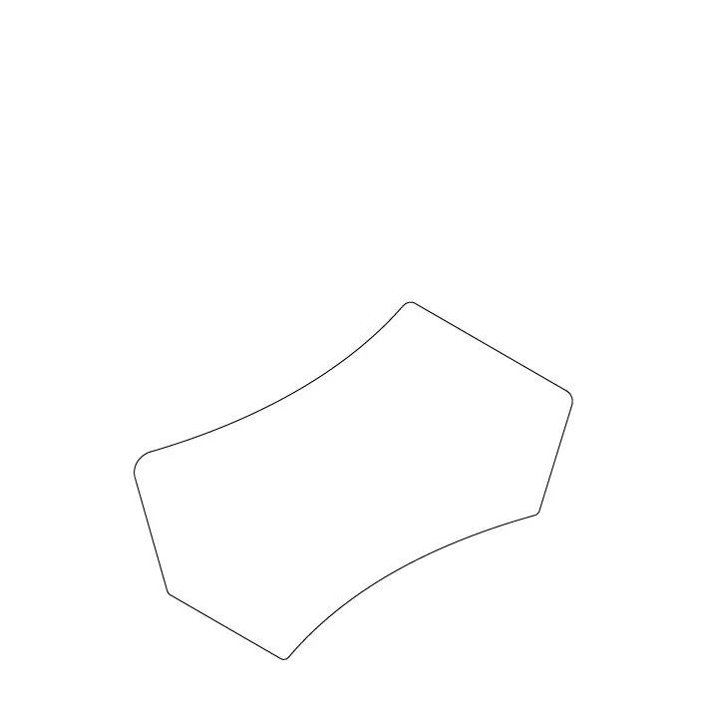
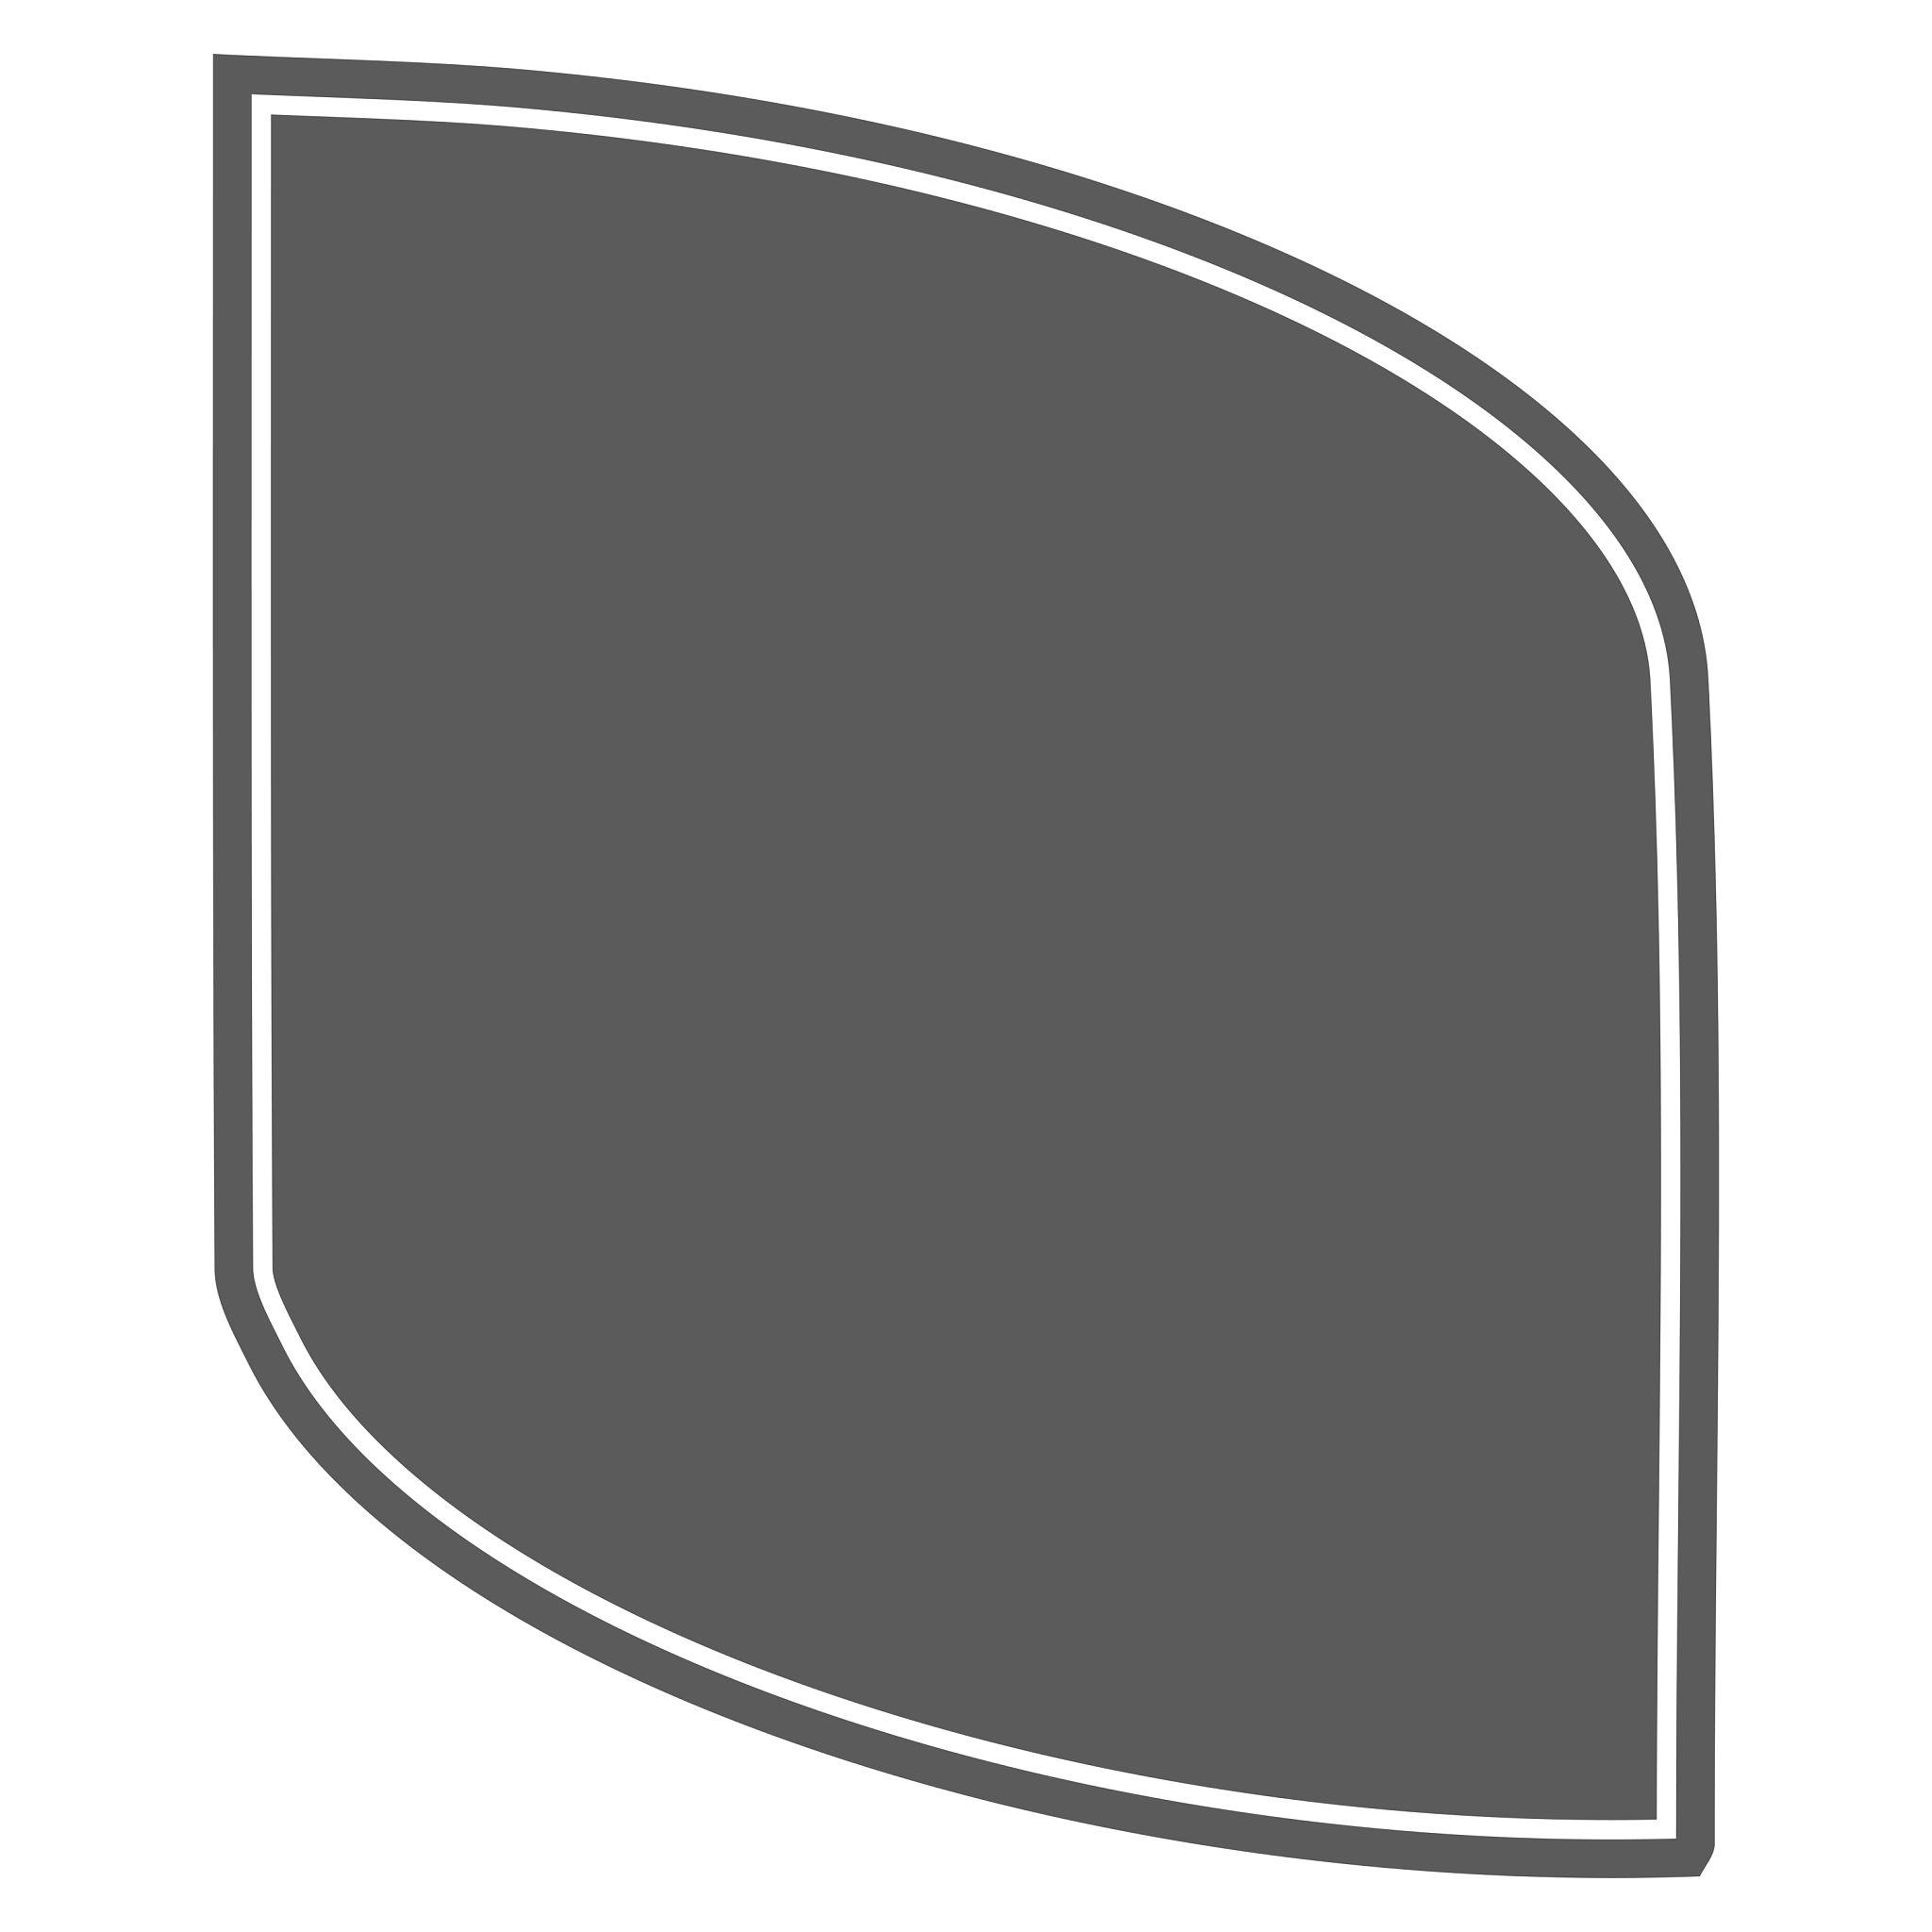
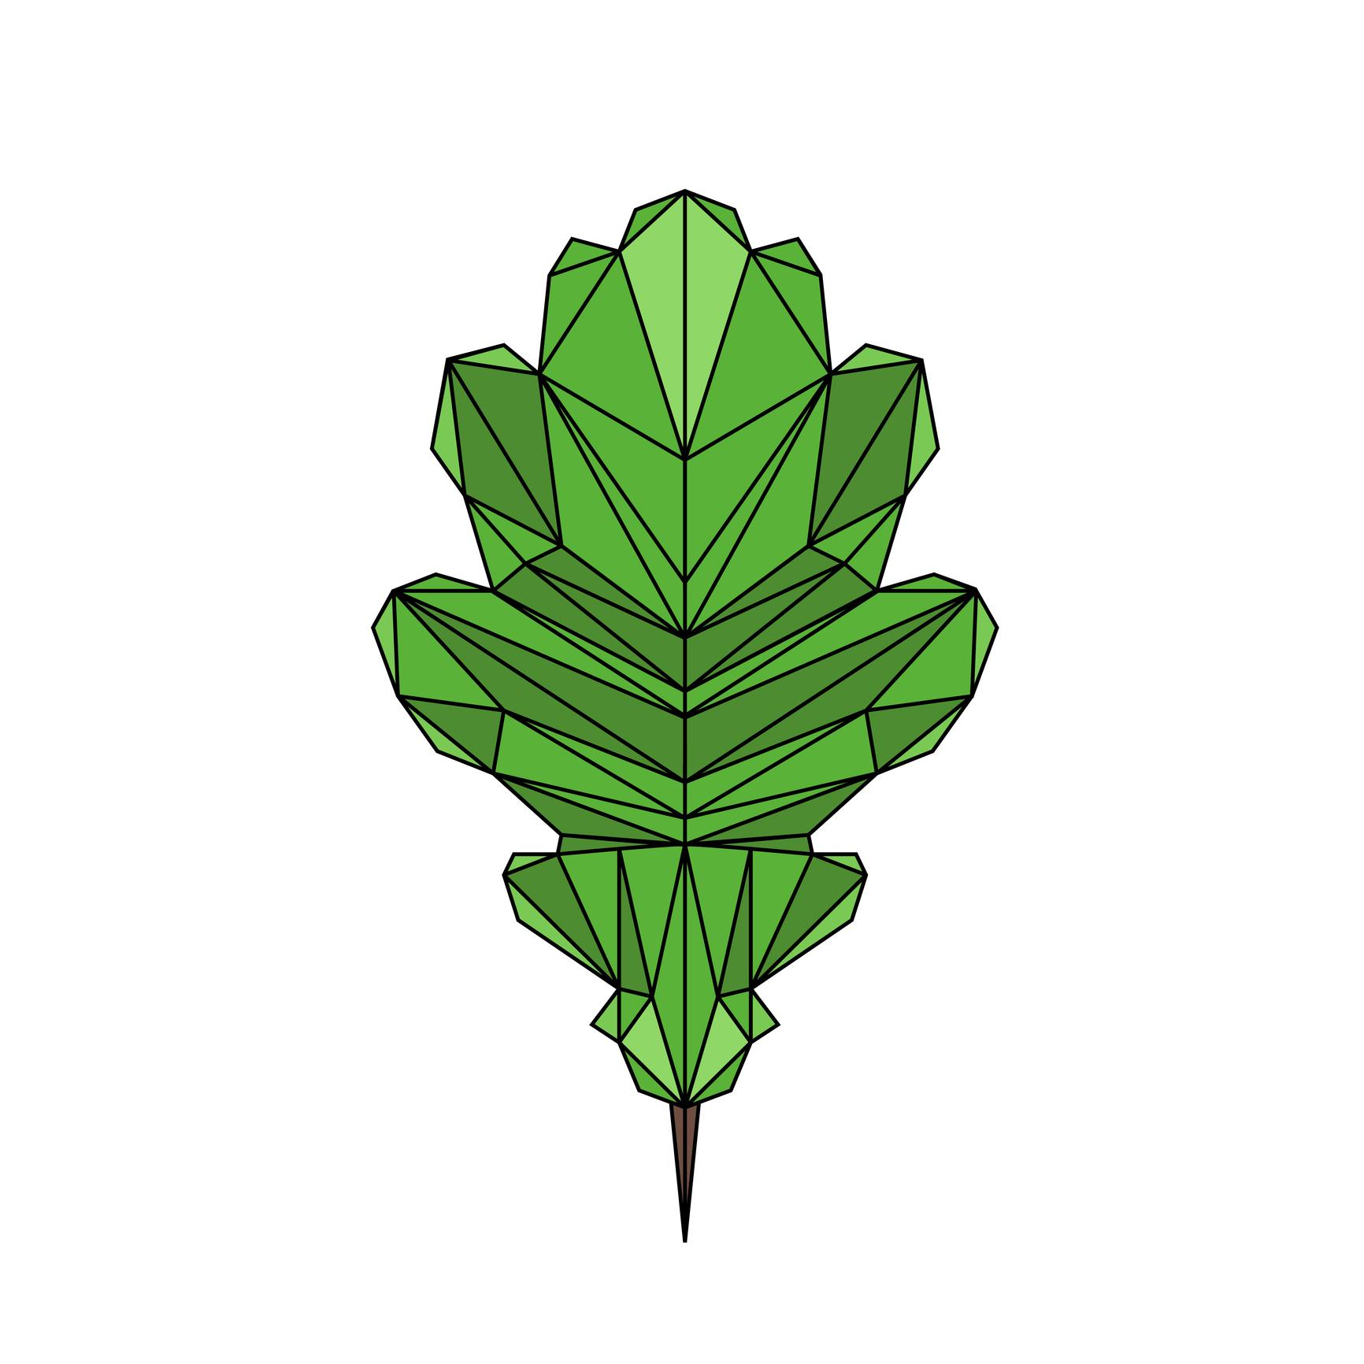
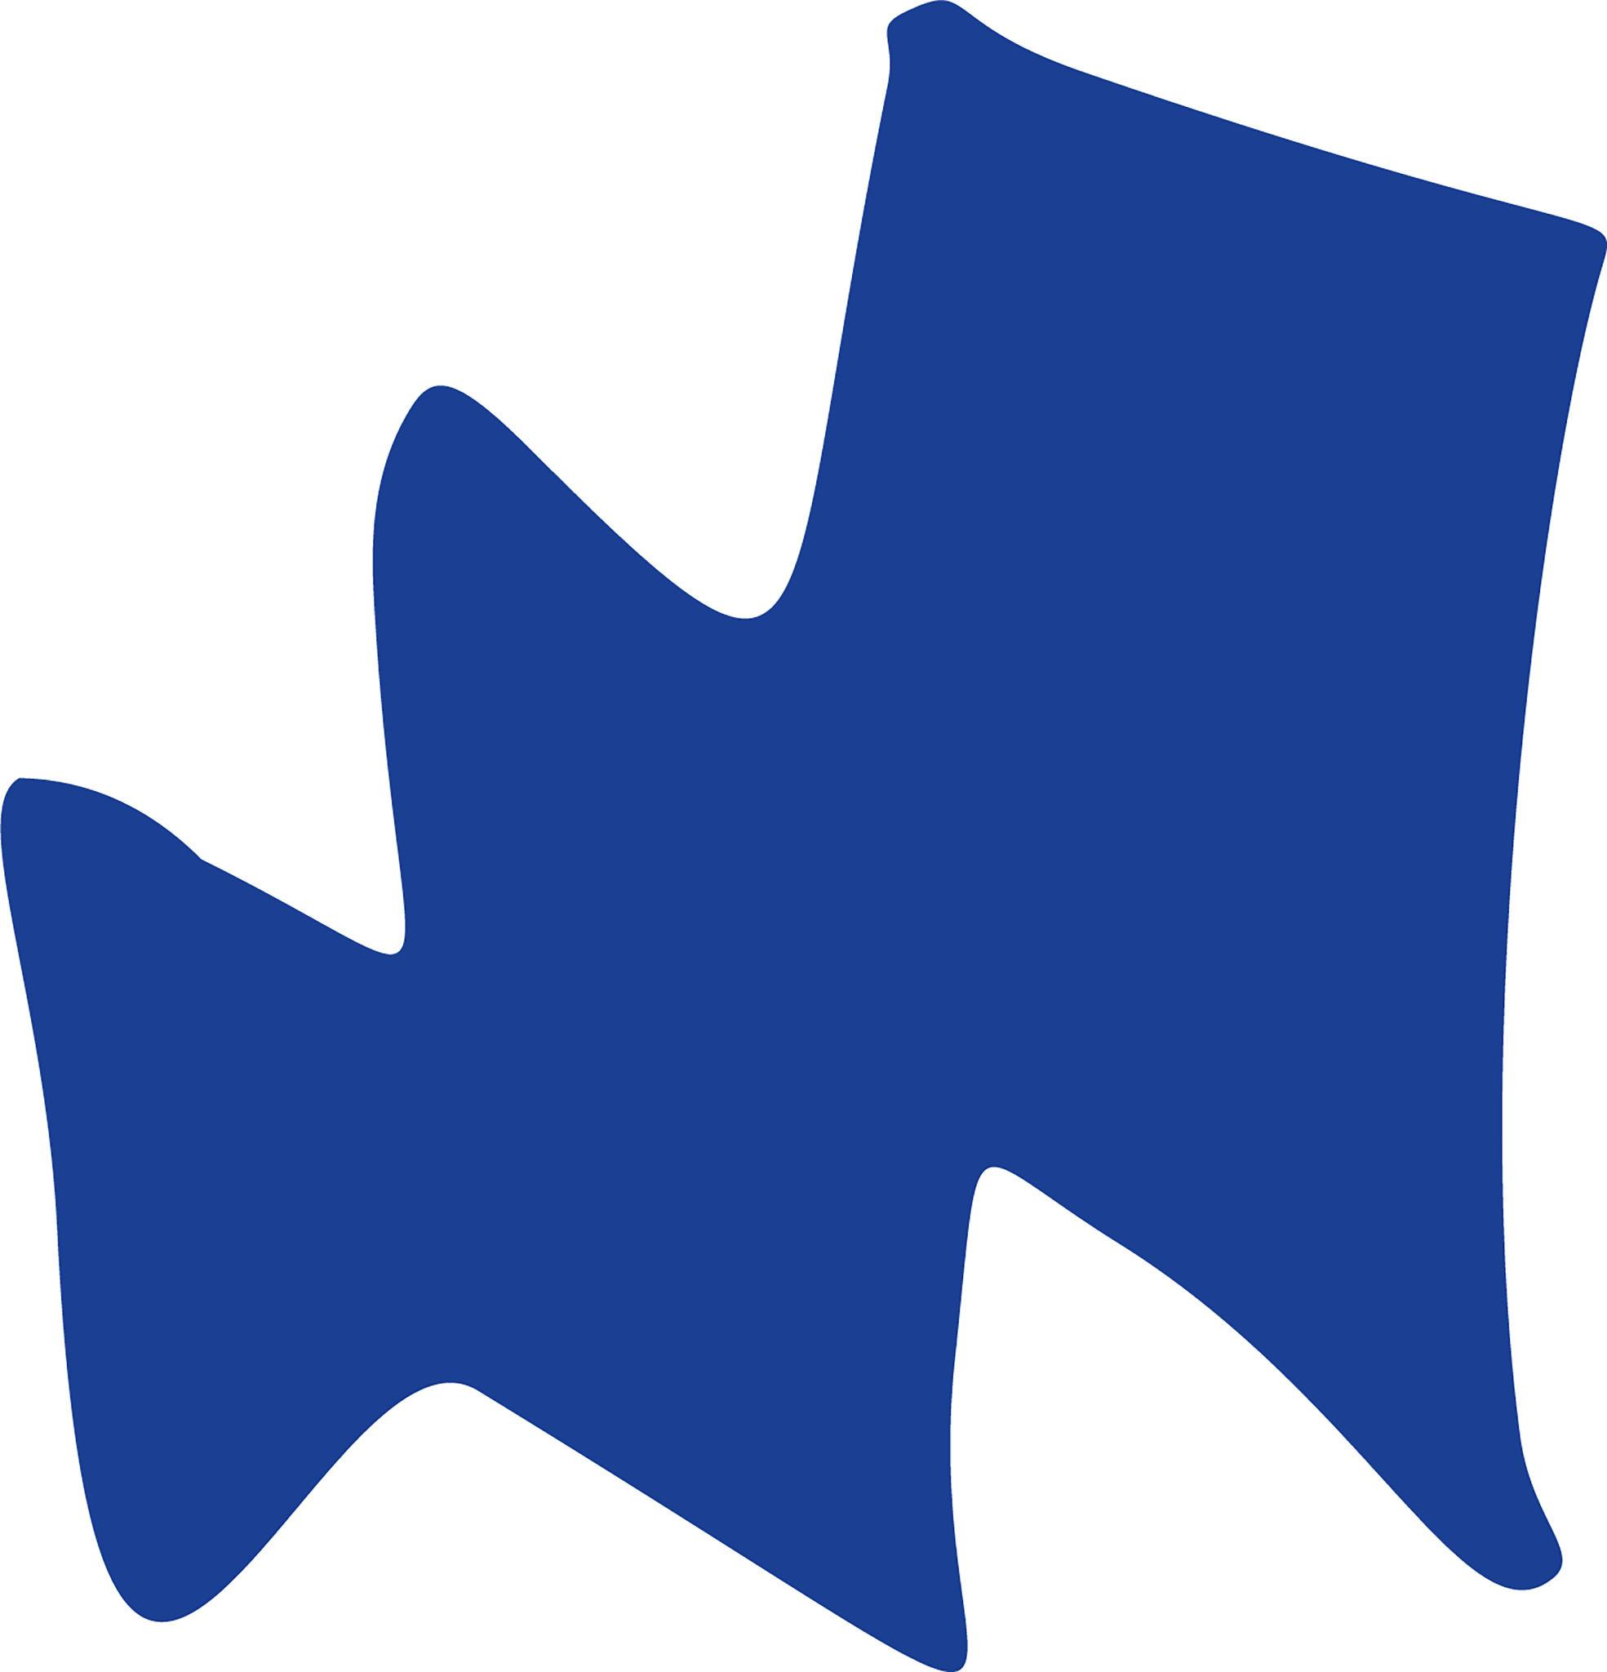

Definition
# Source: AI Source: Provided by: [Data Path: Persons Table -> ID Column: 1, Name_En Column: Motasem Essam] -> From: [ChatGPT] on [7/25/2026]
A Polygon–Organic Mixed Shape is an irregular mixed shape that combines polygonal elements, such as straight edges and vertices, with smooth, organic-looking curved elements.
In simple terms:
It is a shape that combines geometric straight-line parts with free-flowing, natural-looking curved parts.
$$\boxed{\text{Polygon–Organic Mixed Shape}=\text{Polygonal Elements}+\text{Organic Curved Elements}}$$

Characteristics
# Source: AI Source: Provided by: [Data Path: Persons Table -> ID Column: 1, Name_En Column: Motasem Essam] -> From: [ChatGPT] on [7/25/2026]
A polygon–organic mixed shape typically:
- Contains at least one straight boundary segment.
- Contains at least one organic curved boundary.
- Has both geometric and free-flowing characteristics.
- Is generally irregular.
- May have different types of curvature along its boundary.
- Does not necessarily have symmetry.
- May enclose a bounded region.
- Does not usually correspond to one standard geometric formula.
- Can be created intentionally or resemble a natural object.

Examples

1. Polygon with an Organic Curved End
# Source: AI Source: Provided by: [Data Path: Persons Table -> ID Column: 1, Name_En Column: Motasem Essam] -> From: [ChatGPT] on [7/25/2026]


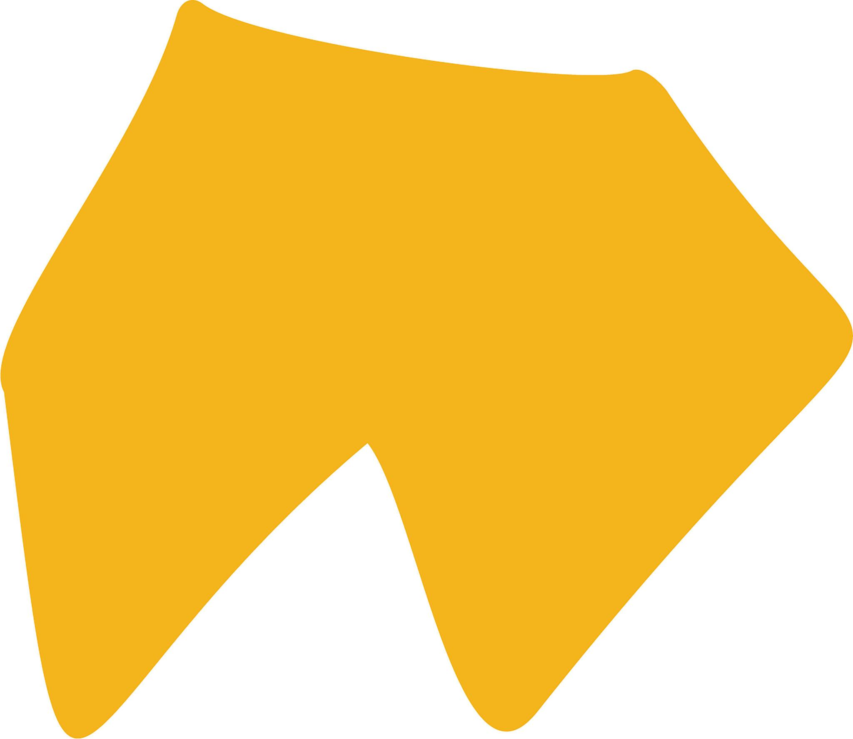
A polygonal section can be joined to a smooth, irregular curved section.

2. Polygon–Leaf Mixed Shape
# Source: AI Source: Provided by: [Data Path: Persons Table -> ID Column: 1, Name_En Column: Motasem Essam] -> From: [ChatGPT] on [7/25/2026]
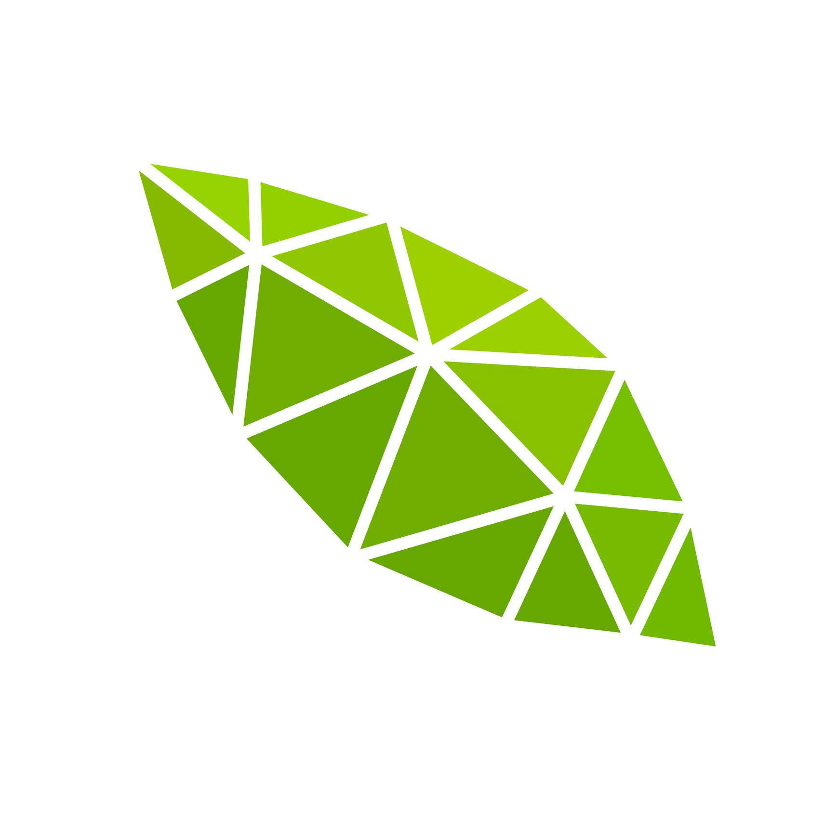
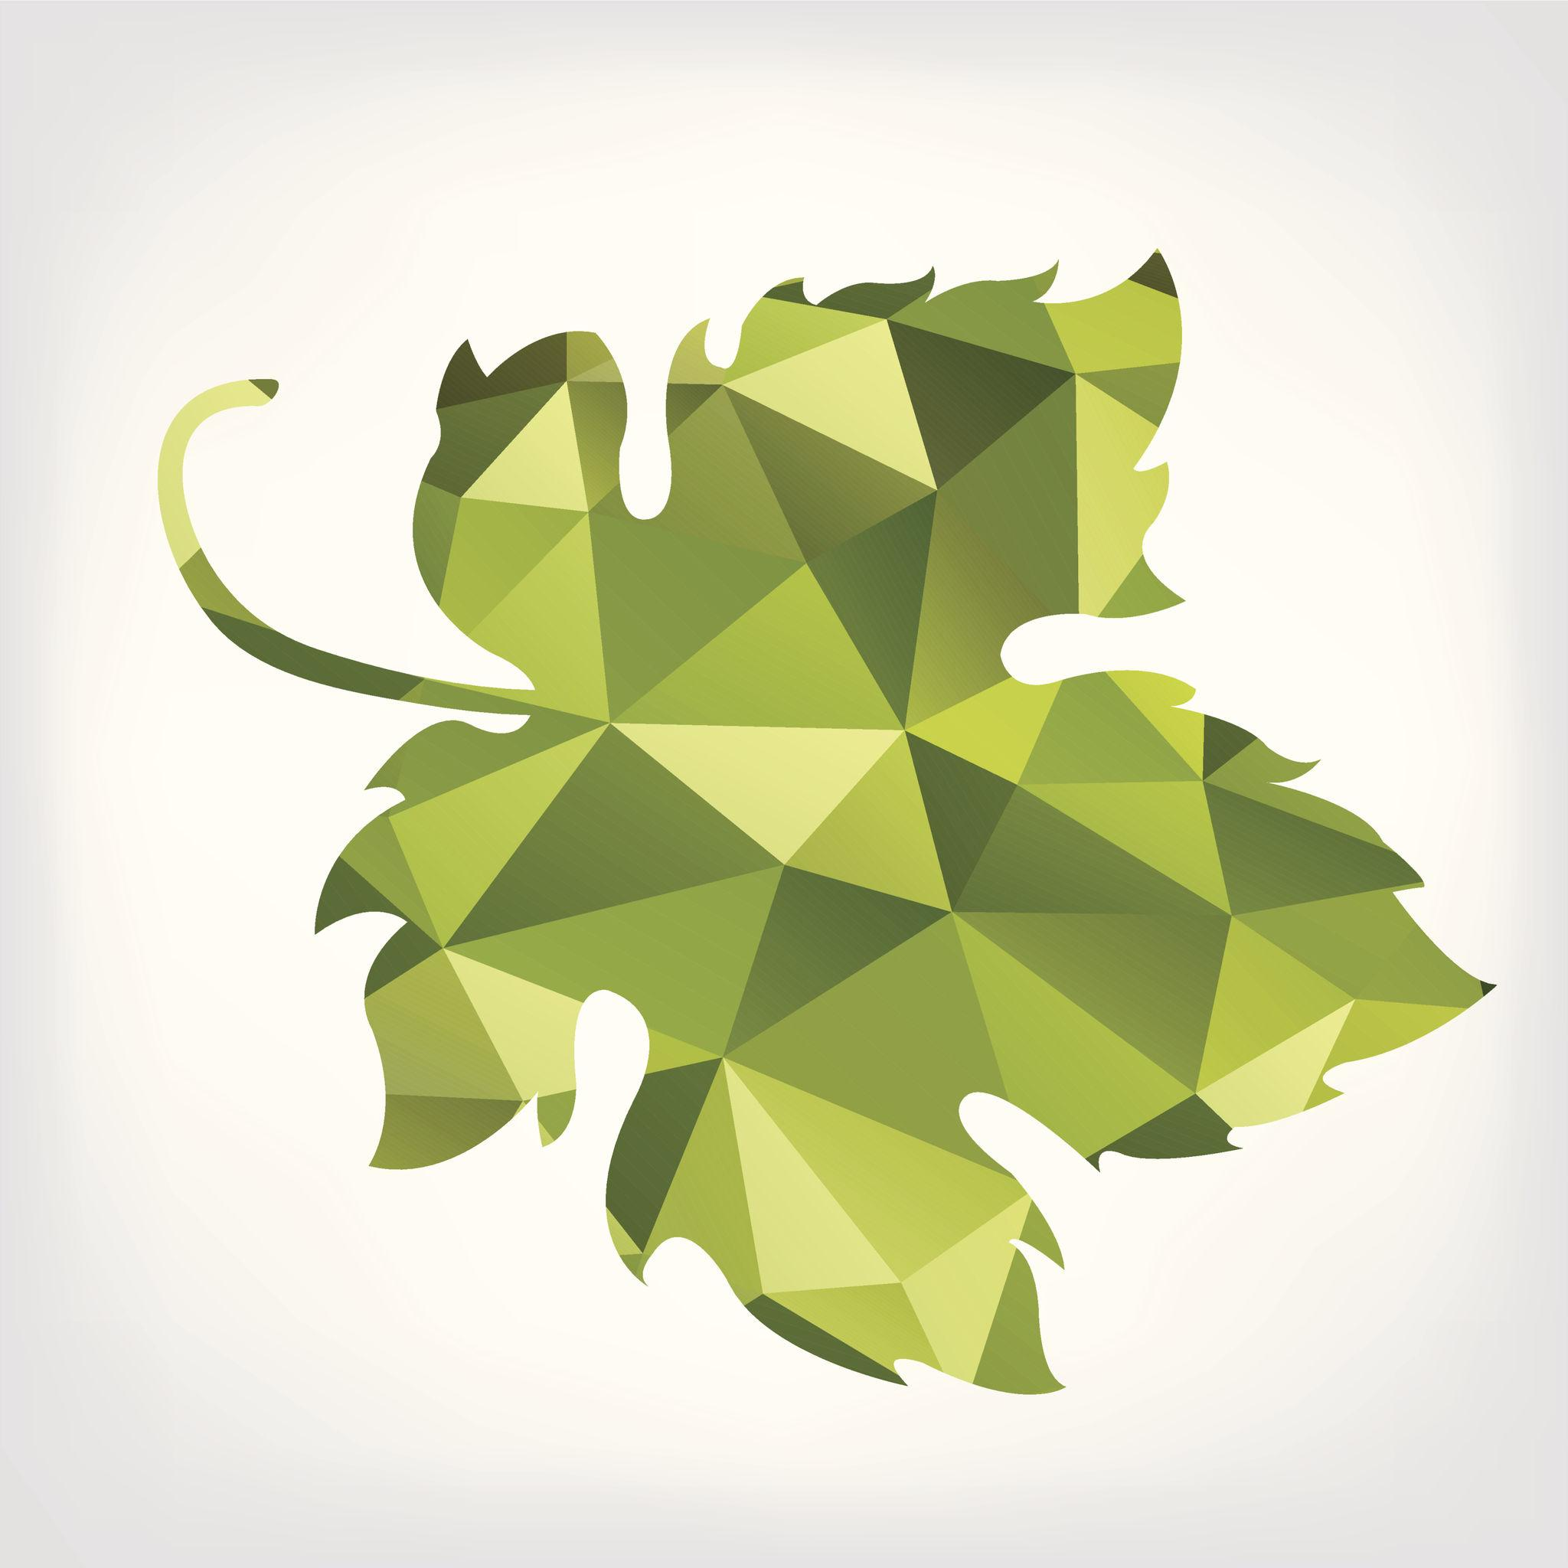
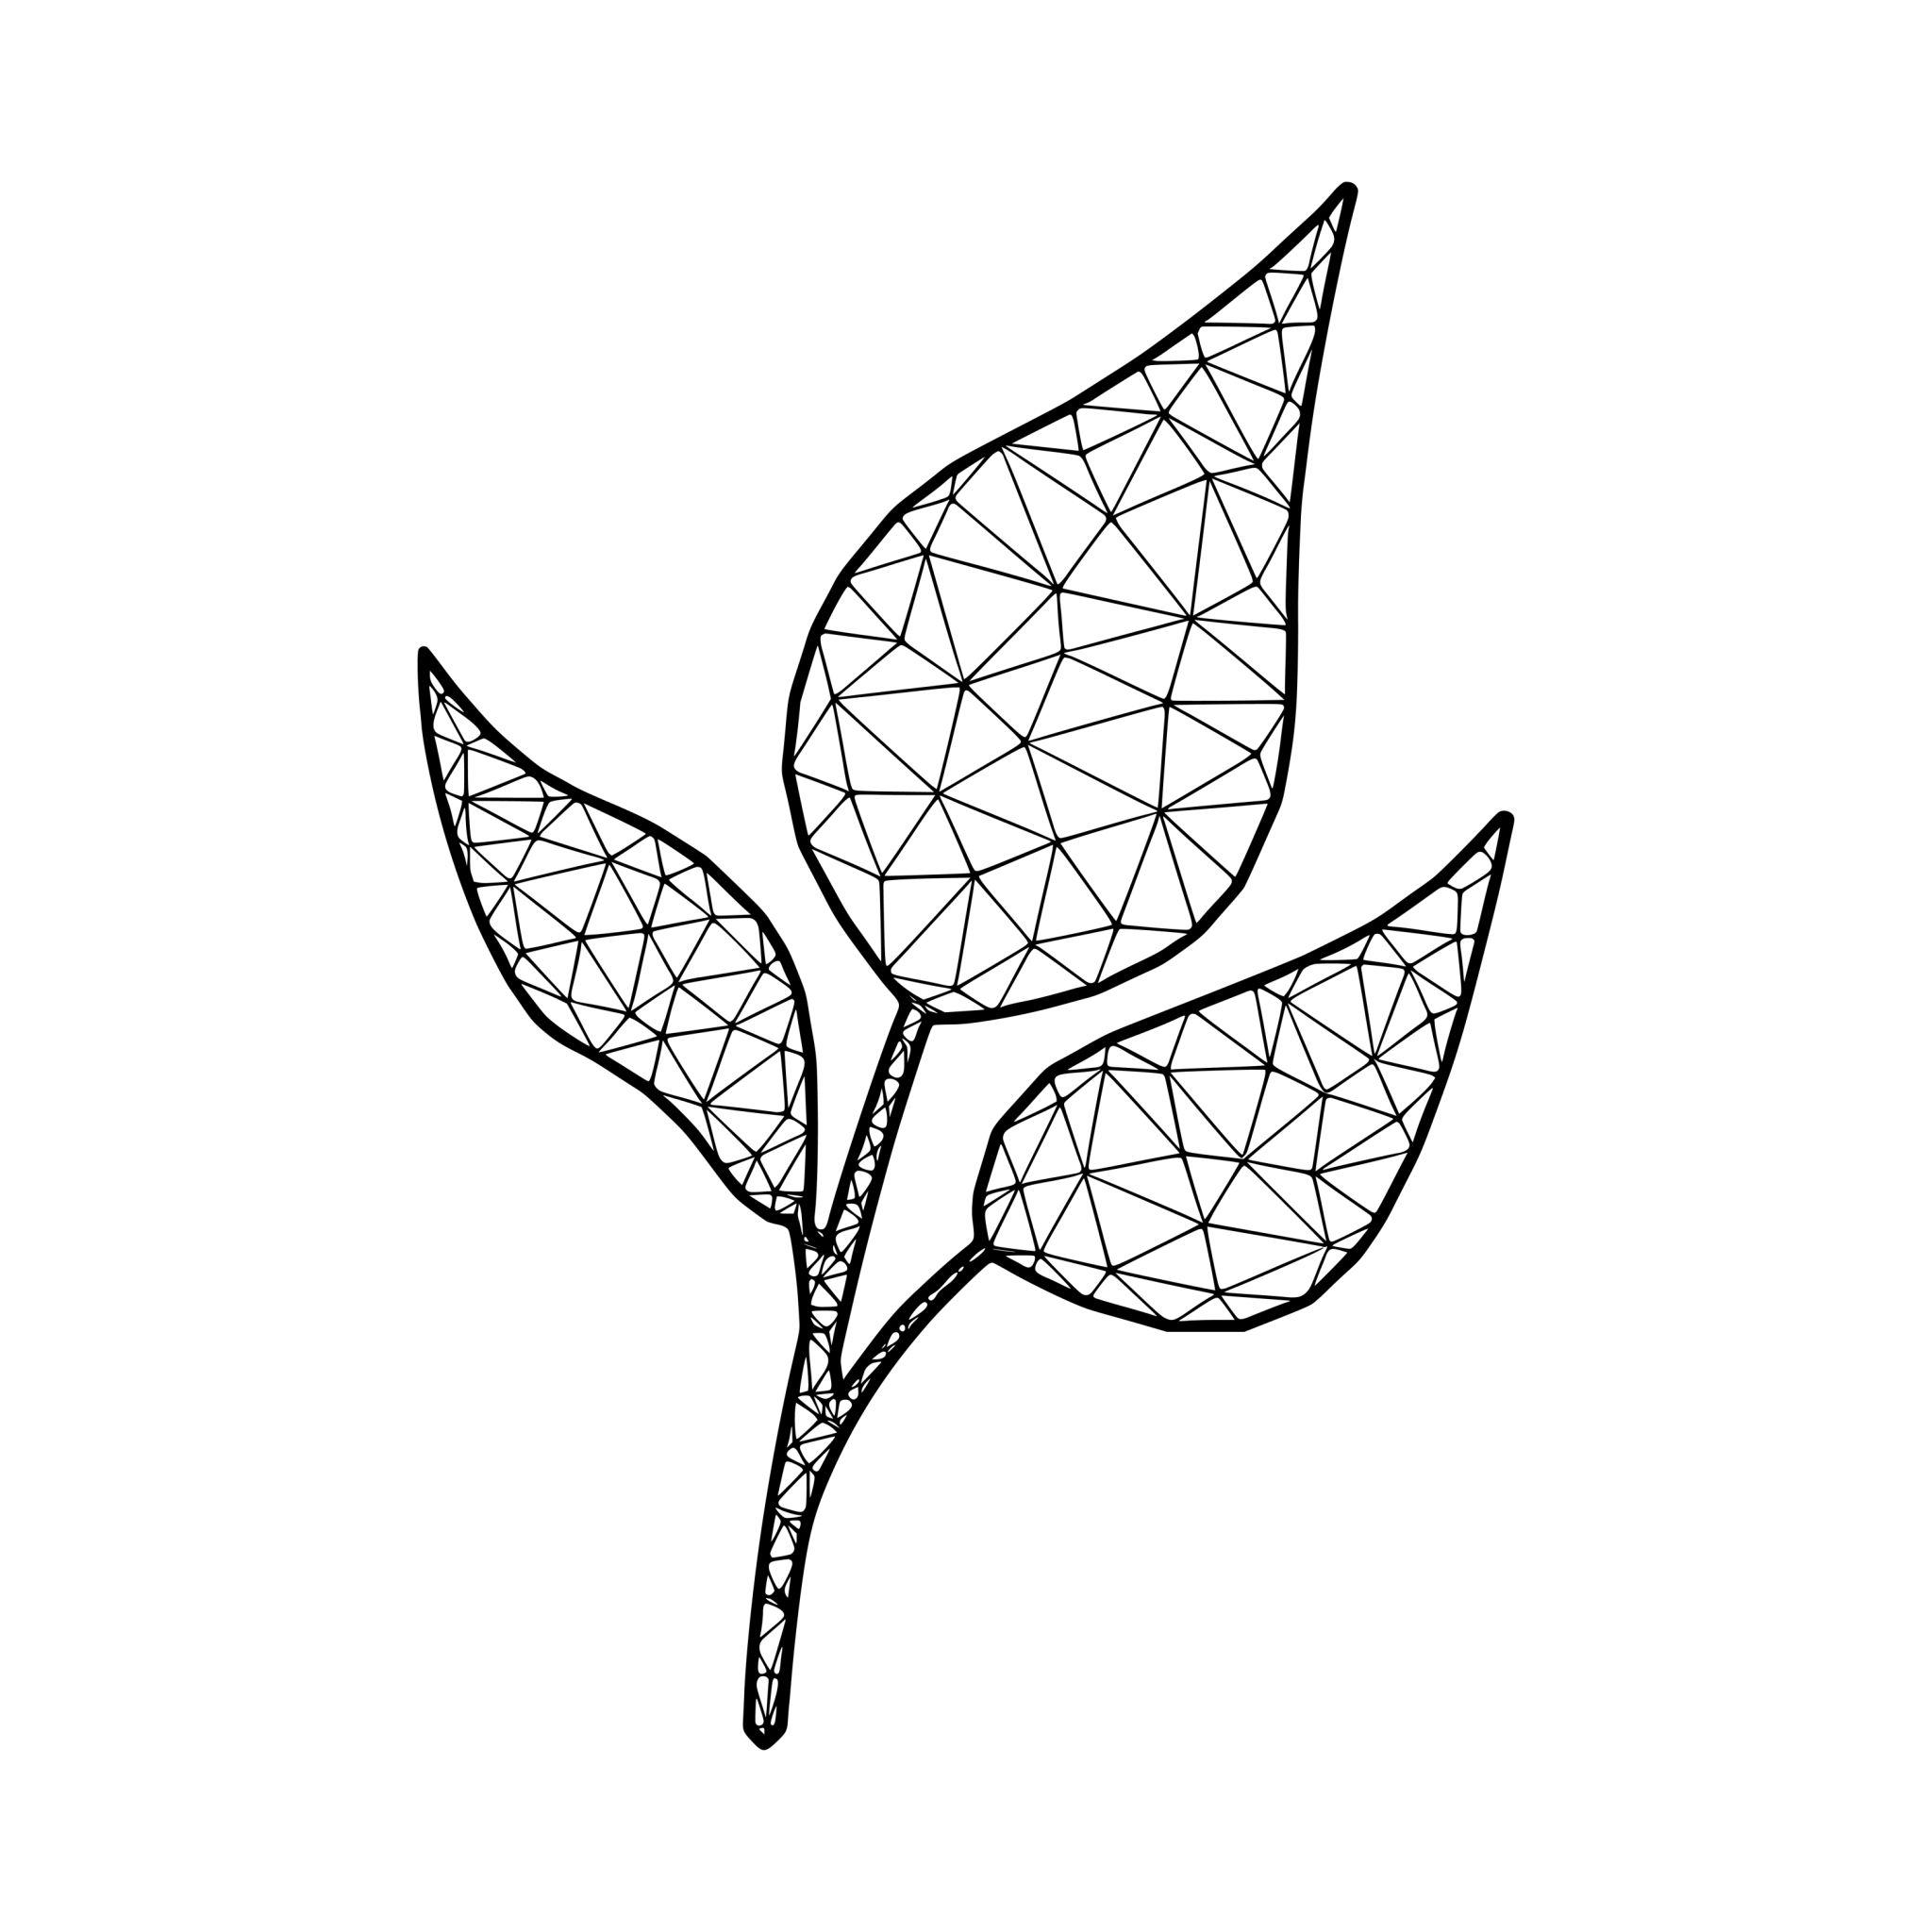

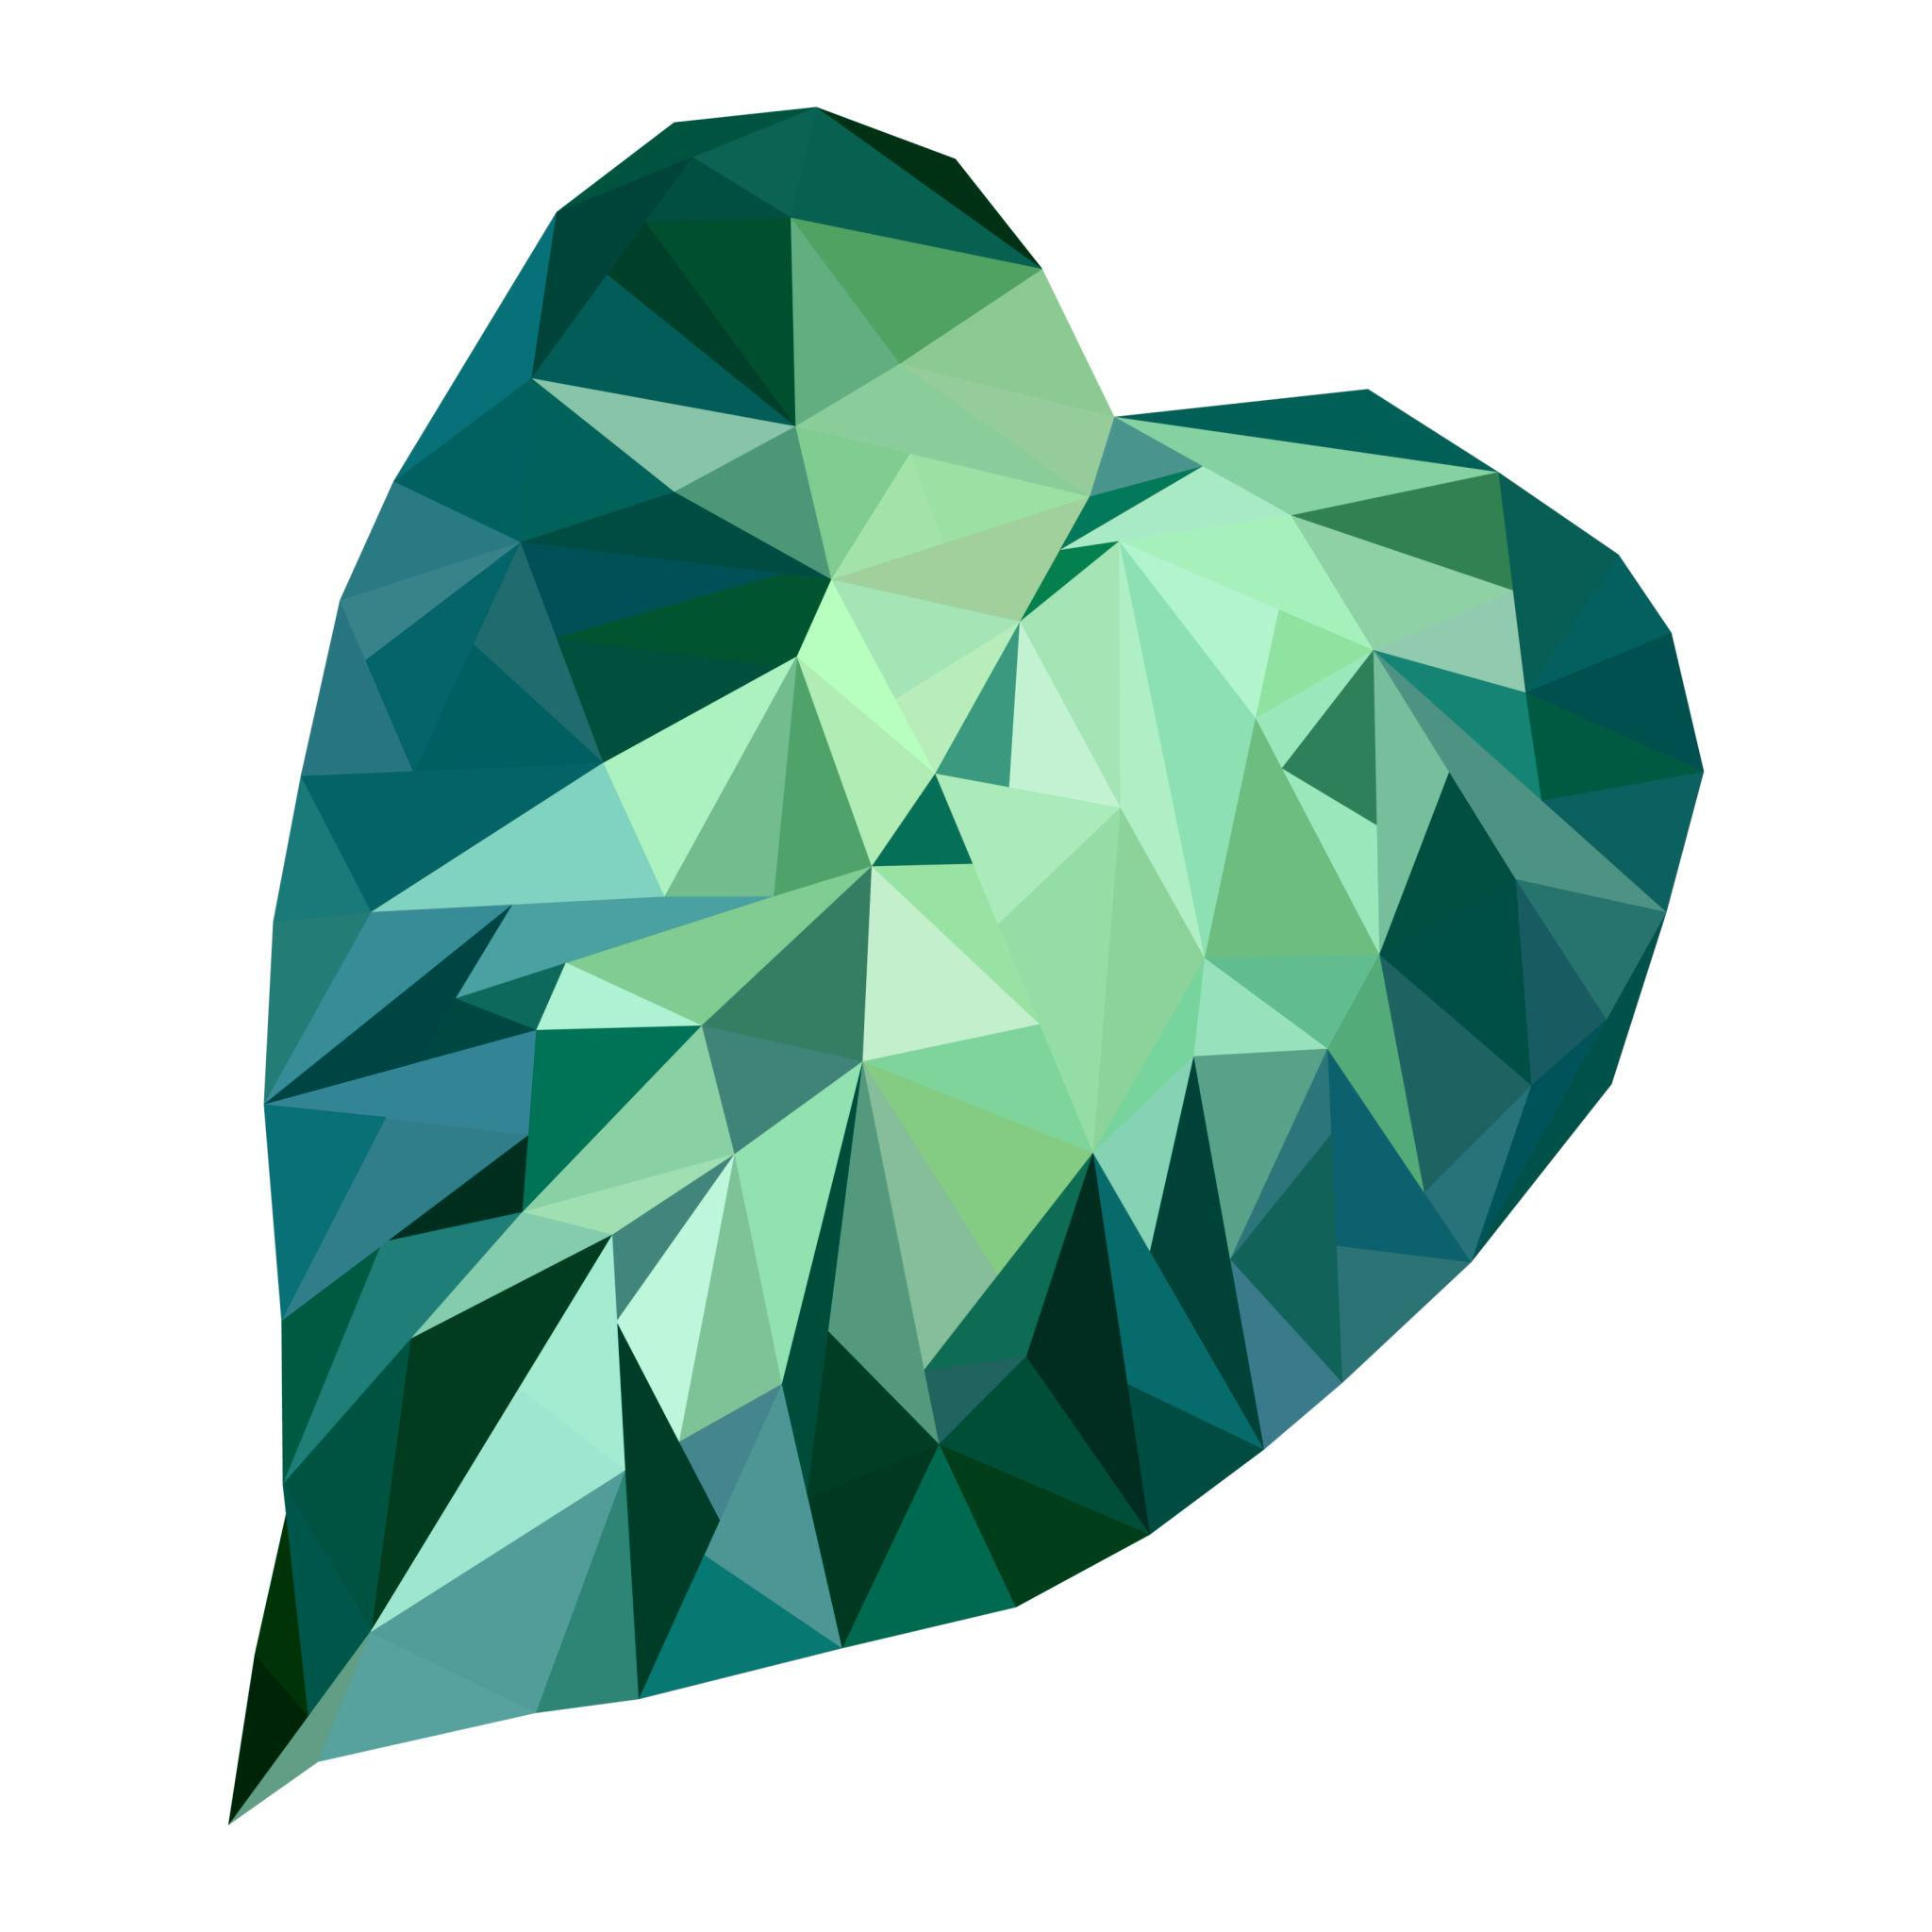

A shape may combine straight polygonal portions with a leaf-like organic curve.

3. Polygon with Organic Bulges
# Source: AI Source: Provided by: [Data Path: Persons Table -> ID Column: 1, Name_En Column: Motasem Essam] -> From: [ChatGPT] on [7/25/2026]
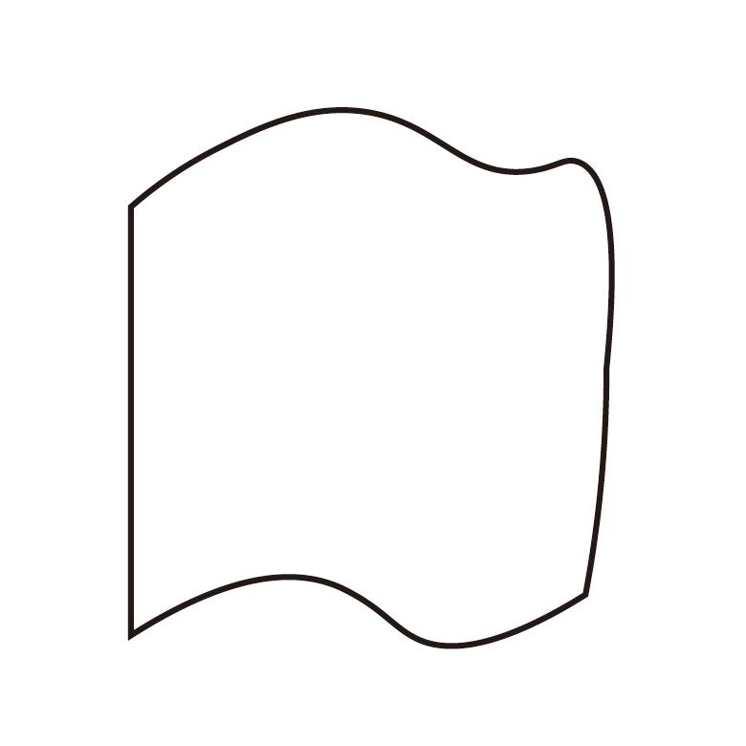

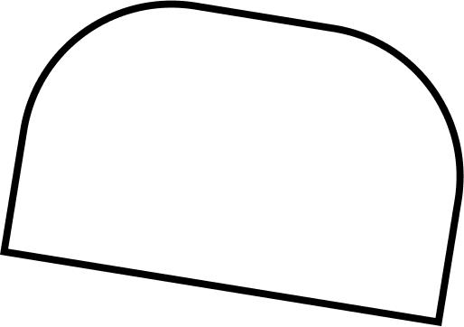
Some composite shapes contain several straight edges interrupted by smooth, irregular bulges.

4. Geometric–Organic Composite Design
# Source: AI Source: Provided by: [Data Path: Persons Table -> ID Column: 1, Name_En Column: Motasem Essam] -> From: [ChatGPT] on [7/25/2026]

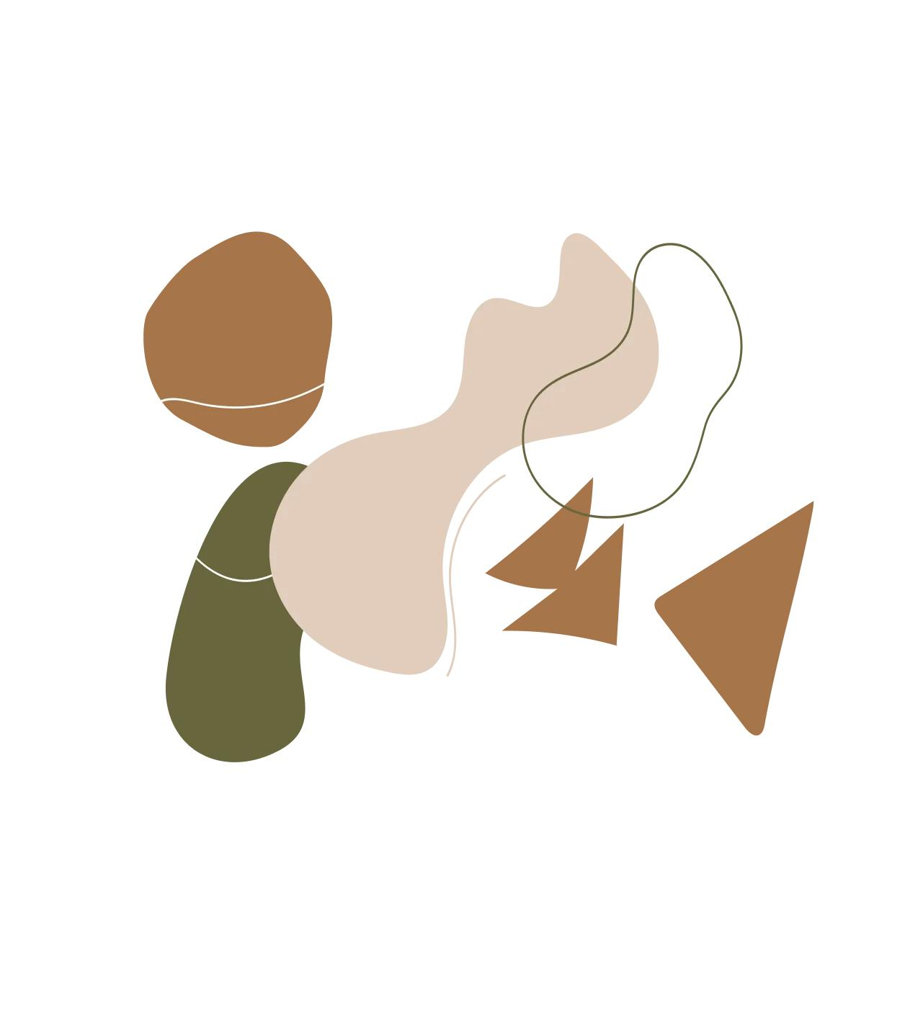

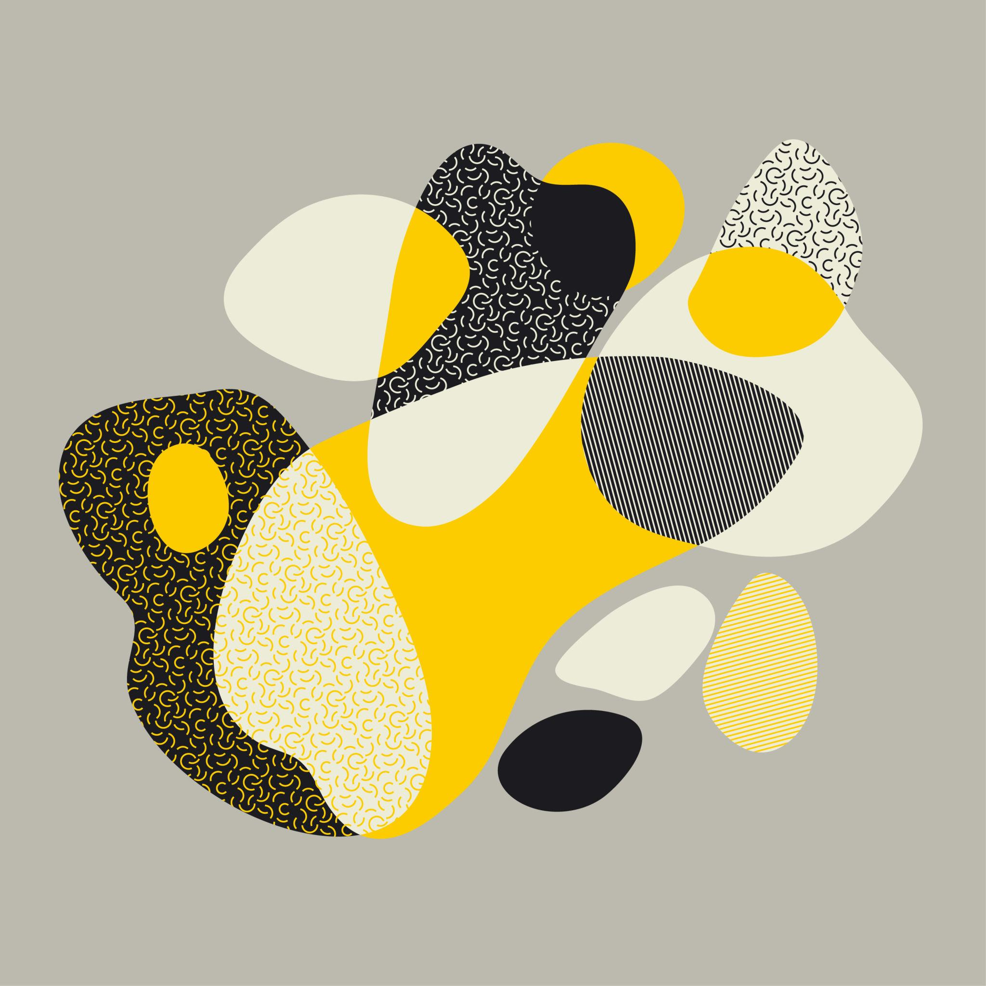
These combinations are common in logos, architecture, product design, and illustration.

5. Polygon–Organic Natural-Looking Shape
# Source: AI Source: Provided by: [Data Path: Persons Table -> ID Column: 1, Name_En Column: Motasem Essam] -> From: [ChatGPT] on [7/25/2026]

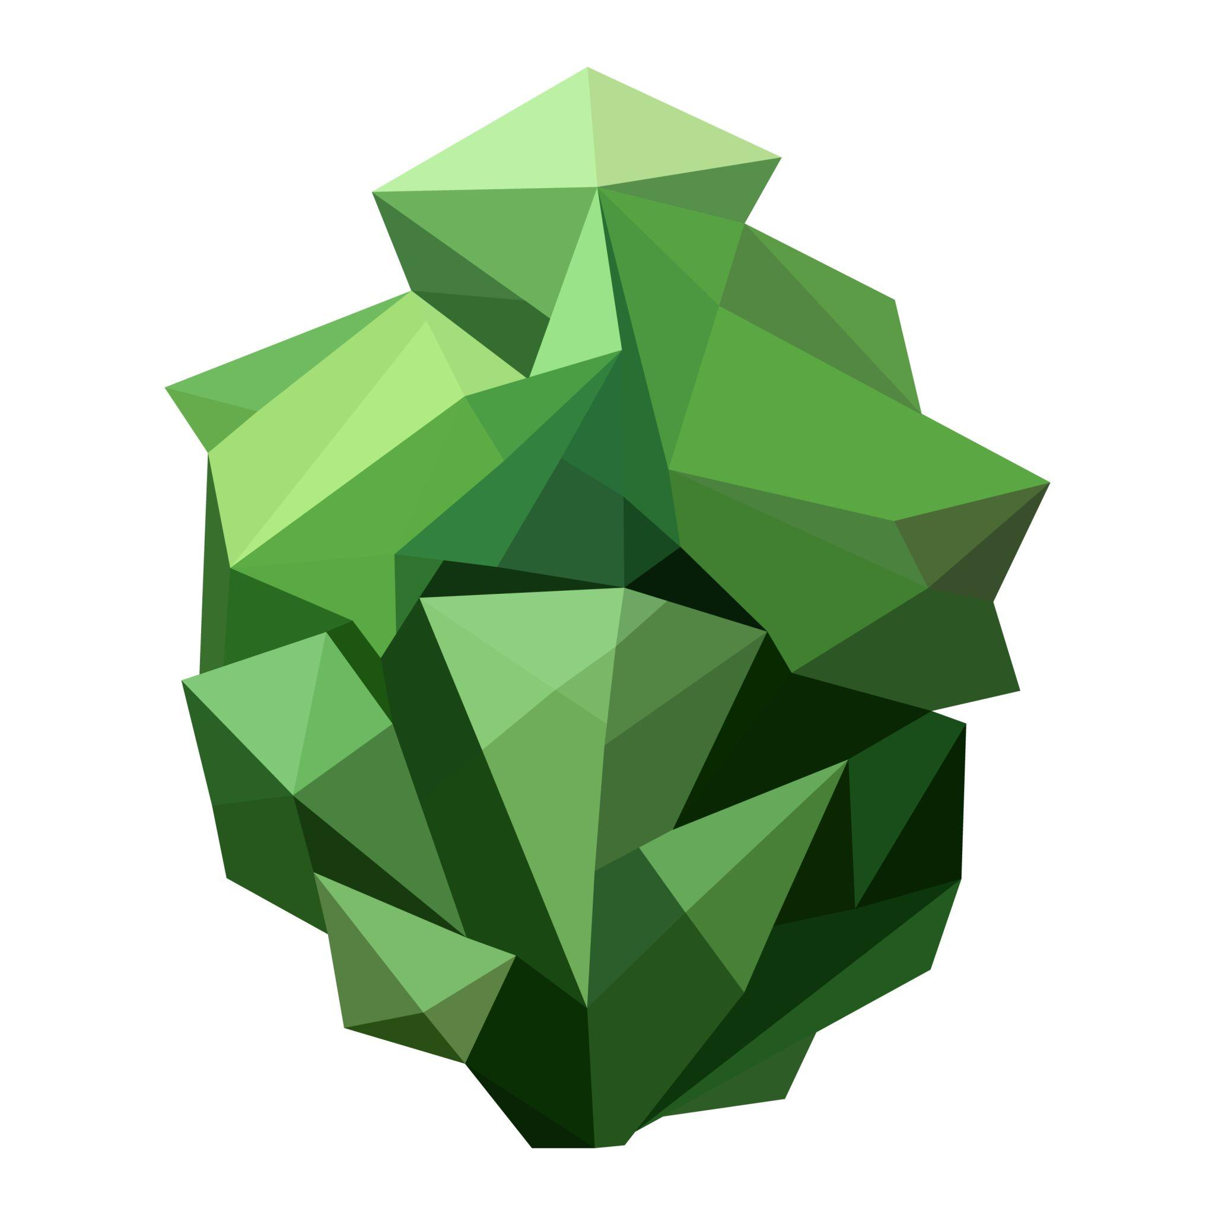
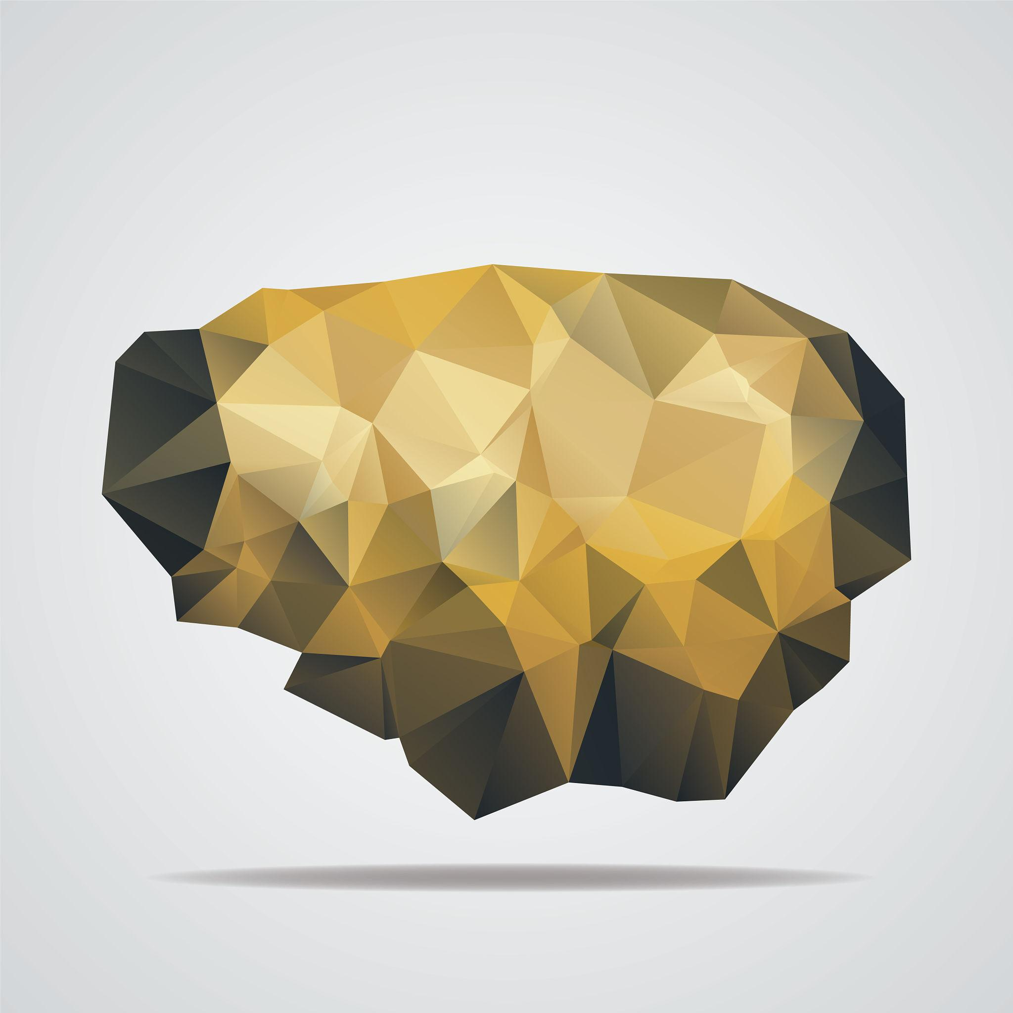
A shape can have a partly geometric boundary and a partly natural-looking curved boundary.

Boundary Classification
# Source: AI Source: Provided by: [Data Path: Persons Table -> ID Column: 1, Name_En Column: Motasem Essam] -> From: [ChatGPT] on [7/25/2026]
The boundary of a polygon–organic mixed shape contains both:
$$\boxed{\text{Straight Boundary}+\text{Organic Curved Boundary}}$$
Therefore, it can also be classified as a mixed boundary.
For example:
$$\boxed{\text{Mixed Boundary}=\text{Polygonal Straight Segments}+\text{Organic Curved Segments}}$$

Polygonal Component
# Source: AI Source: Provided by: [Data Path: Persons Table -> ID Column: 1, Name_En Column: Motasem Essam] -> From: [ChatGPT] on [7/25/2026]
The polygonal component consists of straight-line segments connected at vertices.
For example:
$$A→B→C→D$$
where each connection is a straight segment.
The polygonal portion may be:
- Triangular
- Quadrilateral
- Pentagonal
- Hexagonal
- Or another irregular polygon

Organic Component
# Source: AI Source: Provided by: [Data Path: Persons Table -> ID Column: 1, Name_En Column: Motasem Essam] -> From: [ChatGPT] on [7/25/2026]
The organic component is characterized by:
- Smooth curvature.
- Variable curvature.
- Natural-looking flow.
- Lack of rigid geometric regularity.
- No requirement for a constant radius.
It can be represented by a freeform curve:
$$x=x\left(t\right), y=y\left(t\right)$$
rather than a standard circular equation.

Area
# Source: AI Source: Provided by: [Data Path: Persons Table -> ID Column: 1, Name_En Column: Motasem Essam] -> From: [ChatGPT] on [7/25/2026]
A polygon–organic mixed shape can often be divided into simpler parts:
$$\boxed{A_{\text{total}}=A_{\text{polygon}}+A_{\text{organic region}}}$$
or, when part of the shape is removed:
$$\boxed{A_{\text{total}}=A_{\text{polygon}}-A_{\text{removed}}}$$
The organic portion generally requires numerical methods, approximation, or coordinate data unless its curve has a known mathematical equation.

Perimeter
# Source: AI Source: Provided by: [Data Path: Persons Table -> ID Column: 1, Name_En Column: Motasem Essam] -> From: [ChatGPT] on [7/25/2026]
The perimeter combines the straight and curved portions:
$$\boxed{P=\sum{L_{\text{straight}}}+\sum{L_{\text{organic curve}}}}$$
For an organic curve represented parametrically:
$$x=x\left(t\right), y=y\left(t\right)$$
its arc length is:
$$L=\int_{a}^{b}{\sqrt{{\left(\frac{dx}{dt}\right)}^{2}+{\left(\frac{dy}{dt}\right)}^{2}}}dt$$

Polygon–Organic vs. Polygon–Circular Mixed Shapes
# Source: AI Source: Provided by: [Data Path: Persons Table -> ID Column: 1, Name_En Column: Motasem Essam] -> From: [ChatGPT] on [7/25/2026]
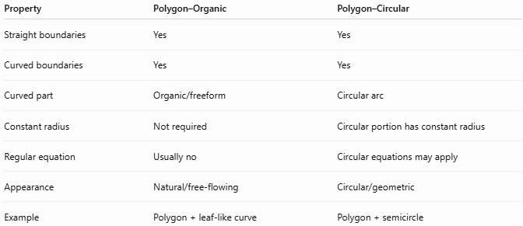
Property | Polygon–Organic | Polygon–Circular
Straight boundaries | Yes | Yes
Curved boundaries | Yes | Yes
Curved part | Organic/freeform | Circular arc
Constant radius | Not required | Circular portion has constant radius
Regular equation | Usually no | Circular equations may apply
Appearance | Natural/free-flowing | Circular/geometric
Example | Polygon + leaf-like curve | Polygon + semicircle
The key difference is:
$$\boxed{\text{Organic Curve}≠\text{Circular Arc}}$$

Polygon–Organic vs. Organic Shapes
# Source: AI Source: Provided by: [Data Path: Persons Table -> ID Column: 1, Name_En Column: Motasem Essam] -> From: [ChatGPT] on [7/25/2026]
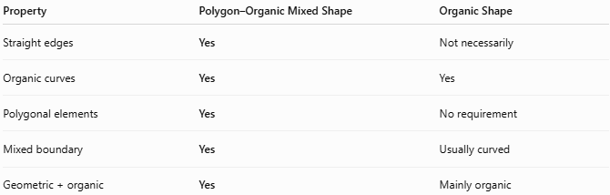
Property | Polygon–Organic Mixed Shape | Organic Shape
Straight edges | Yes | Not necessarily
Organic curves | Yes | Yes
Polygonal elements | Yes | No requirement
Mixed boundary | Yes | Usually curved
Geometric + organic | Yes | Mainly organic

Key Points
# Source: AI Source: Provided by: [Data Path: Persons Table -> ID Column: 1, Name_En Column: Motasem Essam] -> From: [ChatGPT] on [7/25/2026]
A Polygon–Organic Mixed Shape combines:
$$\boxed{\text{Straight Polygonal Parts}+\text{Organic Curved Parts}}$$
It:
- Has straight edges and vertices.
- Has smooth, irregular curved sections.
- Combines geometric and organic characteristics.
- Is generally irregular.
- Can have a mixed boundary.
- Does not require symmetry.
- Can be measured by decomposing it into polygonal and curved components.
- Is useful for describing natural-looking designs, logos, architecture, product forms, illustrations, and biological shapes.

Conclusion
# Source: AI Source: Provided by: [Data Path: Persons Table -> ID Column: 1, Name_En Column: Motasem Essam] -> From: [ChatGPT] on [7/25/2026]
Polygon–Organic Mixed Shapes are irregular composite shapes that combine polygonal elements with organic, free-flowing curved elements. Unlike polygon–circular mixed shapes, their curved portions are not restricted to circular arcs or a constant radius. They provide a useful category for shapes that combine geometric structure with natural-looking curvature, particularly in design, architecture, CAD, illustration, biology, and real-world object modeling.

